Evolution of a Sweet Bag

‘Swete Bags’ are often cited as a container for small gifts or money, or as a container for small confections. Queen Elizabeth I of England is documented to have received many embroidered sweet bags among her New Year’s gifts as all higher nobles and Bishops were obliged to give gold coins in ornamental bags for New Year’s. These are described as having colorful embroidery on them and in this paper I will review a few extant examples of these types of bags in comparison with my attempts to recreate such an item.

History
16th Century England was a time of increasing wealth and one way to display that wealth was through richly embroidered fabrics. Previous to this time period, those with money enough to have fine embroidered robes and gowns would bequeath them to the Church and they were subsequently made into religious vestments. The Tudor era was a time of relative peace so great houses saw a return of prosperity. Upholstery, curtains, borders on linens as well as highly elaborate embroidery on clothing were all ways in which people displayed this wealth. Jackets, coifs, petticoats, and detachable sleeves could all be decorated with colorful embroidered silks depicting natural elements. Other popular forms were blackwork which primarily used black thread in its designs, but often would have metal threads interspersed in the pattern, and whitework which used drawn thread and reticella, a form of needle lace. A very popular style for using colored silks involved a scrolling ‘vine’ enclosing floral designs. The scroll was most often done in metal thread, while the actual motifs were stylized flowers that were not always to a relative scale and may not have used colors close to those seen in nature. The item could be further embellished with spangles, beads or pearls. Many different types of stitches would be used to add to the texture in the design.

Extant examples
Examples of period bags that I have found in my research are attached in Appendix B with a descriptive comparison chart at the back of this document in Appendix A. The items are dated from 1600-1650, although I would argue that some could be dated earlier, the reason for which will be discussed in the following paragraphs. I have included references to show that the same style of embroidery was being used before 1600.
In reviewing the embroidered designs on the examples (Appendix A), I have found many similarities. Of the ten examples, all use flowers in the design. Bag #1 uses a linen ground. The descriptions accompanying Bags #2 and #3 states that they are canvas, while Bags #5, #6 and #7 specify linen canvas, while bag #10 has been worked on velvet. Bag #4 is on paper, and I believe this one to be the latest example, as it deviates the most from the others. Further, there is an embroidered coat of wool from 1673 that seems to have a very similar aesthetic. 6 of the examples, #’s 1, 3, 7, 8, 9, and 10, have the characteristic scroll work around the flowers. These are the items that I believe could be dated slightly earlier than 1600. Their similarity in design to each other, and to other items that can be dated to the latter part of the 1500s makes me believe that could have originated earlier than 1600.
Bags #2 and #7 seem the “plainest”, as their designs are the most simplistic with repetition of the same elements. When speaking of things relating to fashion, they often start small and progress until they can be rendered larger that life. Pattens to keep your shoes out of the mud are a fine example of this as they could be seen as the beginning of tall chopines. Farthingales and bum rolls eventually turned into 18th century panniers which could make the wearer several times their ordinary width at the waist. This is where I begin to think these plainer items may be earlier. Bags #6 and #7 use individual motifs instead of the repeated ones; they maybe the next step in the evolution, and the adding of the scrolling design to tie the elements together would be the step beyond that. They all seem to be dated 1600 and after, but there are references to sweet bags in the lists of New Year’s gifts at least as early as 1577. Unfortunately, the descriptions do not indicate exactly what the bags looked like, but they are embroidered and use various colors and metal threads. These examples here would fit that description. The pieces shown in Appendix C are examples of Elizabethan embroidery that are not sweet bags, but once you examine the individual motifs and the stylized way some are drawn I believe the bags must be of a similar date and method. While this does not mean the extant examples are dated wrongly, but perhaps the starting date could be 1575 instead of 1600.
By looking at both Appendix A and Appendix C you will notice that flowers dominate the motifs used in the embroideries. Flowers may have been foremost in many Elizabethans minds as the garden was almost as important as the house itself. Taste and refinement were demonstrated by the layout and scale of the garden. A “knotted garden” forming fret or arabesque patterns was extremely popular and Bag #2 would easily compare to such a layout. Books of engravings containing plants and emblems were also used as inspiration for embroidered work.
The ground fabric most used in period examples is linen or a linen canvas. In looking at the extant examples I have gathered, I noticed that many seem to be done on a natural or unbleached ground and that white linen does not appear to have been used for sweet bags. I had not looked at the color of the background, just its material as I assumed a white linen ground would have been preferable. A white ground is normally used for coifs, undress jackets and chemises.
I had thought these bags could have possible been practice pieces for the aforementioned items as many of the embroidery techniques used can be seen on all items, but George Digby supposes them to be professional work. Raphael Holinshed notes that during the 1570’s one of the chief skills for the ladies at Court was embroidery and domestic embroiderers would get a professional or a draughtsman to draw the design. When professional embroiders were hired on to a household, the profession was not always listed and they do seem to be hired on for limited periods of time and not as permanent household staff. When a period account specifies pay to an embroiderer, it says how many days worked not what pieces were made, so it can be hard to know which pieces are done by a professional and which by a domestic embroiderer, although, metal thread was believed to be highly skilled when done on wool or silk and so was almost certainly done by professionals. These facts lead me to think that perhaps they could be either, a home embroiderer practicing or a professional doing one for a gift.
All the bags appear to have been finished with narrow trim along all sides and the same trim is used for drawstring closures and length to either, carry, hang off a belt or attach to something else. One possible method to create this trim would be with finger loop braiding. It is very hard to tell just from photographs, but the Purse-string pattern from Compleat Anacronist #108: Fingerloop Braids done in the colors instructed two colors would produce trim like the ones seen on Bag #1 and Bags #6, Bags #3, #4, and #7 look as if the same technique is used, but with only one color. Bag #2 appears to have a design like “A Grene Dorge” from Tak V Bowes Departed and Bag #5 looks as if it is finished with “An Endented Lace” from the same publication. Each bag also has 3 tassels or a small grouping of decorative beads along the bottom edge, except Bag #7 which only has 2. All but Bag #1 have 2 drawstrings for the closure, so I am not sure if these variations are on purpose or the elements have been lost over time. All the drawstrings are finished with decorative finials that are covered using similar thread to that used in the bag embroidery itself. The accompanying descriptions, from the collections where they are housed, (some with more detail than others) do not mention what these items are made from. None of the descriptions mention anything on the reverse side of the bag from the embroidery. This leads me to believe that the opposite side is devoid of decoration.

Reproduction
Design:
This is a style of embroidery I greatly enjoy. It is small, so you do not feel overwhelmed by the project, but there is still much variety in the way it can be executed and it usually results in a useful object. I have completed 5 bags in an effort to understand the aesthetic of these small objects and have found them immensely useful. They can be used to cover non-period items like a digital camera or keys, as well as useful objects for events. I now use one for my order medallions and another for game tokens. Sweet bags first caught my eye in an article in “Leisure Arts” magazine. Since the application of stitches was designed to appeal to a broad range of modern embroiderers, it is more linear in the design that would have been used in period. The colors used also seem to be more Jacobean than Elizabethan, as they are more muted and more dusty looking, however the motifs are not necessarily inappropriate The way the motifs are arranged is more formal and symmetrical in design and while many Elizabethan coifs sleeves have repeated designs, they are not generally mirrored off a central axis as in this design. I was not brave or knowledgeable enough at the time to vary from the published pattern.
Attempt number 2 was also from a pattern in a magazine, called “Fine Lines” this time. Stylistically, it is closer to the Elizabethan aesthetic as demonstrated by the motifs used, elements found in a garden and the “scroll” design connecting the motifs. The stitches used were also typical of period examples, detached buttonhole, trellis, tent and the plaited braid stitch.
My third sweet bag was the first time I designed any embroidery project on my own. At the time I still did not fully understand the composition of design. Floral motifs and animals are used extensively in 16th century embroidery and there is an extant example of a stag on a sweet bag in the Victoria and Albert Museum (V&A) which led to my choice of primary design motif. I wanted to do something completely different from the other 2 bags I had done, so I chose a deer beside a tree without leaves. I now see that the overall effect is not correct. There is not “enough” in the design, as there are usually several motifs, or if it is more abstract, the design covers the entire surface. This was also the first bag where I incorporated the tassels seen on many existing examples.
With my fourth bag, I was more conscious of the choices in relation to the period look that I wanted to achieve. I knew flowers would be the main theme and a common layout for period bags uses five flower motifs with an animal. The main heraldic charge in my arms is a violet. My Laurel, at the time, Mistress Bess Darnley, has an iris as her main charge, and I had 2 other apprentice sisters at the time, plus one who had just been elevated. Lady Aurelia has a trillium on her arms. Mistress Isobel Mowbray uses an otter, and Lady Sorcha the Red, is still fairly new to the SCA and has not picked heraldry yet, so I chose a red rose to represent her. This completed the five motifs, since I have five flowers and an animal as a central motif. (see examples)
The fifth bag is very similar in design to the fourth. I have 5 flowers chosen, plus an animal, an insect in this case. It is a gift for Mistress Bess, and my choices were based on both meaningful elements to her as well as period examples. There is a bee for Bess, as well as the iris she has in her arms. Bess’s chosen period within the SCA is Elizabethan, so the other elements, a honeysuckle, heartsease, and a primrose were mostly picked due to the fact that they are very common in the embroidery of the time, in fact I can find 16th century examples of each embroidered motif.

Embroidery Technique and Construction:
I have used cotton embroidery thread for most of the stitching. Silk is used in the existing period pieces, but my only access to silk is mail order, and I would prefer to be able to handle a material before purchasing it for use. I have ready access to DMC cotton floss colors so that I can choose whichever shade I wish (and if run out I can easily get more to finish projects).
A variety of stitches are used to complete the design, including: detached buttonhole, trellis, chain, holbein (double running), short, long and plaited braid stitch. I also couched the bee’s wings in silver thread for additional detail. The chain and holbein stitches are used for outlines of the motifs as well as for a base for other stitches. I find the detached buttonhole works better off of the holbein stitch, while the trellis is better paired with a chain stitch. I decided to use short and long stitch on the heartsease, because it would allow the shading of the flower more easily than the other typical embroidery stitches. I find the detached buttonhole gives a flatter appearance while the trellis appears more rounded and raised. I used trellis stitch on the honeysuckle as its flowers are rather tubular, and rounded. The iris has a combination of trellis and detached buttonhole to add dimension, and the primrose is detached buttonhole, solely because I wanted to have the raised petals, and that is the only stitch I know of that will achieve that affect.

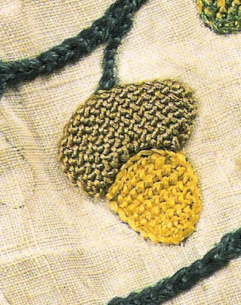
This Detail is from “Fashions in Detail” page 25. It is from an embroidered linen jacket dated 1600-1625. The acorn cap is done in trellis stitch and the nut has been complete with detached buttonhole.

The plaited braid stitch seems to be hard to replicate in the modern world. With the 2nd bag I made, I did some plaited braid on it using DMC metallic floss, and it appears too thin. I have tried stitching with modern silver gilt thread and it kinks where I do not expect it and it does not seem to fill the voids between stitches as seen on embroidered jackets. I tried samples with perle cotton, and differing sizes of Kreinik (a company that produces modern synthetic metallic threads) braids. Perle cotton filled the voids nicely, but is obviously too matte. The #8 braid did the best as it filled the voids without kinking or becoming too lumpy for the scale of the design, so this is what I have chosen to stitch with.
None of the descriptions of the examples say how the bag is finished on the inside. In my opinion the easiest way, and the method I have used for all the bags I have made, was to line the inside with a fold over the top edge wide enough to allow for eyelets for the drawstrings.
The trim on the bag is made from finger-loop braiding. As mentioned above, comparing modern reproductions to the photographs, I believe it is one way to create this braid. It is made of perle cotton from DMC, and as with the embroidery thread, it is due to availability of materials where I live. The pattern for the braiding was taken from Tak V Bowes Departed. The tassels are made from thread matching that used in the embroidery. I have used jump rings to simulate the metal rings used to attach the bags in the extant examples. The beads or “finials”, used at the end of the bag drawstring is made of wooden beads and covered with detached buttonhole stitch in embroidery floss. I have yet to find a source that describes what these finials are made of, perhaps glass beads that are covered, or perhaps they are fabric, or even covered wooden beads
This is my closest attempt to date to reproducing a 16th century embroidered sweet bag of my own design. The motifs chosen are supported by period examples of embroidery depicting the same item, albeit not on an extant sweet bag necessarily. Colored threads on a linen ground are choices supported by the majority of the extant examples. I have finished in an appropriate fashion with trim around it, matching drawstrings ending in covered finials and 3 tassels along the bottom edge. I believe I have achieved a plausible recreation of an item from the 16th century, but would agree it is not a reproduction. Hopefully, the next attempt will be done with silk. AS well, I have now attempted the drawstring finials with fimo and wooden beads and found neither ideal. The fimo is heavy for its size and the wood is not easy to work with as it can chip or splinter while getting it on to the end of the threads, or snag the thread while you are covering it with stitches. I would be very interested to try glass beads at some point, as I am sure this will not be the last sweet bag I create.

Bibliography

Arnold, Janet, “Queen Elizabeth’s Wardrobe Unlocked”, W.S. Maney & Son Ltd, Leeds, Great Britian, 1988

Benns, Elizabeth, and Barrett, Gina, “Tak V Bowes Departed: A 15th Century Braiding Manual Examined”, Soper Lane, UK, 2005

Clarke, Dorothy, “Exploring Elizabethan Embroidery”, Georgeson Publishing Ltd., Auckland, New Zealand, 1997

Digby, George, “Elizabethan Embroidery”, Faber and Faber: London, 1969

Hart, Avril and North, Susan, “Fashion in Detail: From the 17th and 18th Centuries”. Rizzoli International Publications: New York, 1998

Holdaway, Shirley, “Festive Elizabethan Creations”, Georgeson Publishing Ltd., Auckland, New Zealand, 1998

Levey, Santina M, “Elizabethan Treasure: The Hardwick Hall Treasures”, National Trust Enterprises Ltd, London, Great Britain, 1998

Marshall, Sheila, “Elizabethan Needlework Accessories”, Georgeson Publishing Ltd., Auckland, New Zealand, 1998

Novak, Deborah A., editor “Fine Lines”, Historic Needlework Guild Inc: Pittsburgh, PA, Volume 5, Numbers 1-4, Summer 2000-Spring 2001

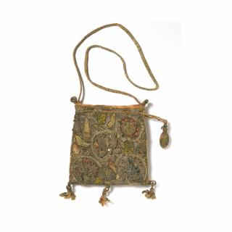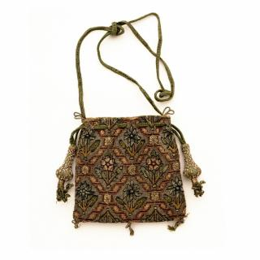

Appendix A
Examples of Extant items
Bag #1
Victoria and Albert Museum
Museum # T.17-1957
Bag #2
Victoria and Albert Museum
Musuem # T.53-1954
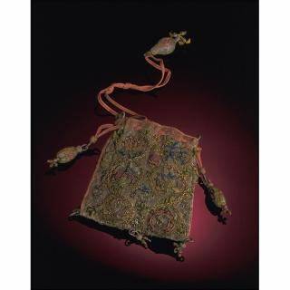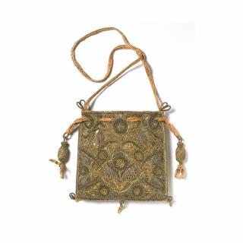

Bag #3
Victoria and Albert Museum
Museum # T.127-1992
Bag #4
Victoria and Albert Museum
Museum # T.10-1922

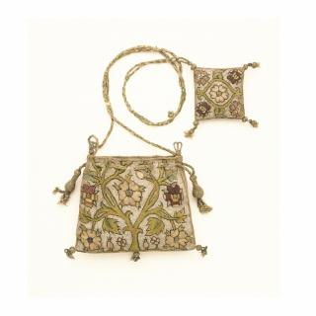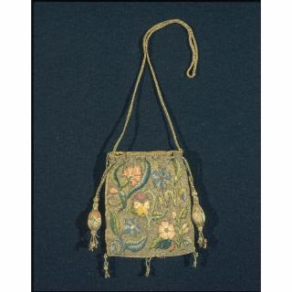

Bag #7
Victoria and Albert Museum
Museum # 316&A-1898
Bag #6
Victoria and Albert Museum
Museum # T.247-1960

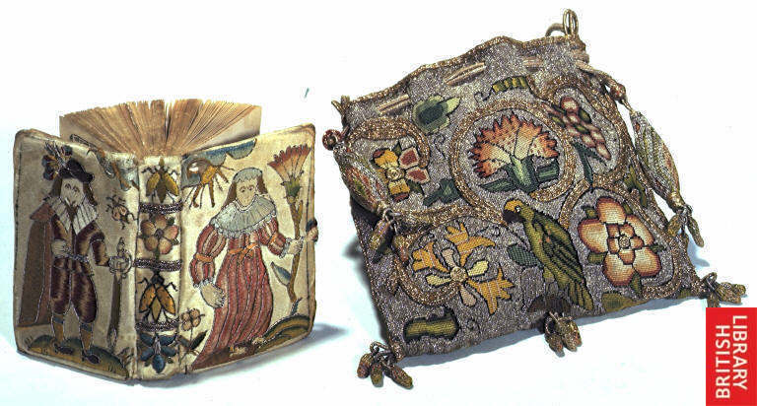
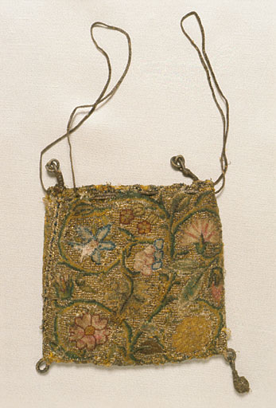
Bag #8 (with Book)
The British Library
Item # c194c27

Bag #7
Manchester Gallery of Costume
Item # 1951.441

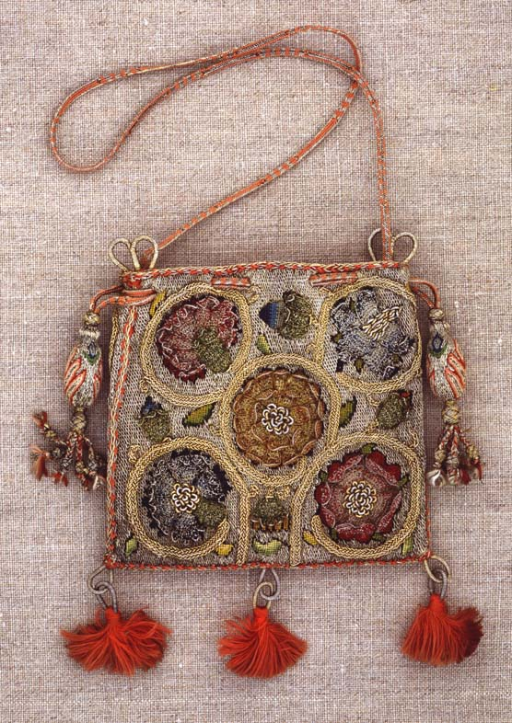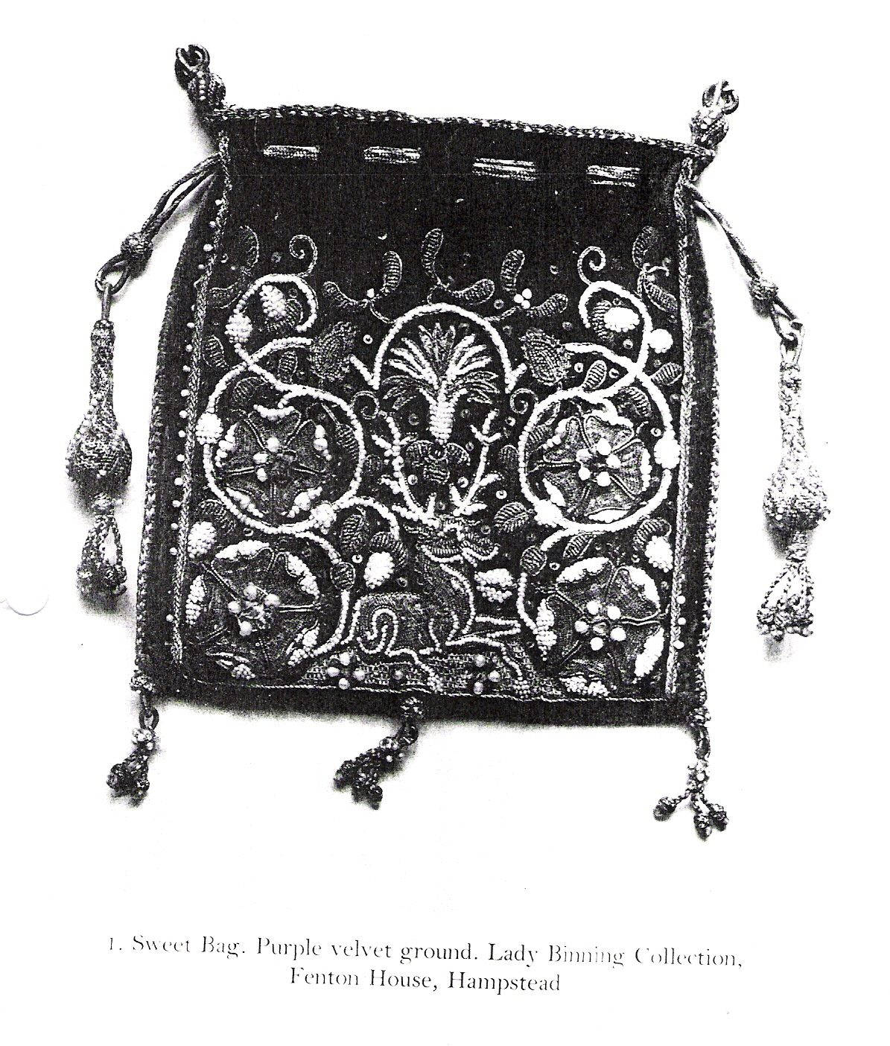
Bag #9
Burrell Collection of Glasgow
City Council
Bag #10
Reproduced from Digby, “Elizabethan Embroidery”

Appendix B
Comparison of Extant Sweet Bags

Identifier | Location | Date Listed | Size | Ground | Materials | Stitches | Description
Bag #1 | V&A | 1600-1650 | unlisted | linen | silver gilt, silver and silk thread | Plaited braid, tent | scroll work filled in with foxglove rose, carnation and leaf motifs. 3 tassles at the bottom, one pull closure with a large bead at the end.
Bag #2 | V&A | 1600-1650 | 13 cm x 14.5 cm | Canvas | metal thread, seed pearls silk, silk braid drawstring | cross, plait, gobelin | Blue pointed-petalled and red rose like flowers and separated by a twisted lattice work design. A white rose-like flower is in the cross-piece of each lattice. 3 tassels were along the bottom and there is a 2 pull closure with large pear shape finials
Bag #3 | V&A | 1600-1625 | 14.5 cm x 12.6 cm | canvas | silk, metal |  | vertical scroll work with flowers, roses, carnation. Scroll done in prominent gold. 2 pull closure with oval tassels. 3 tassels along the bottom.
Bag #4 | V&A | 1600-1635 | 11.7cm x 11.1 cma | paper | silver gilt, silver and spangles |  | the least "colorful" of the examples I have; only gold and silver used, flowers are simple round shape. No scroll work. 2 pull closure with oval tassels. 3 tassels along the bottom.
Bag #5 | V&A | 1600-1626 | 11.5cm x 14 cm | Linen canvas | silk and silver thread | tent gobelin | design is a rose tree. Either colors have faded or overall effect was to use the same value of shades except for red in flowers. 2 pull closure with pear shaped tassels. Holes for the closure look to have been worked right over design. 3 tassels along the bottom.
Bag #6 | V&A | 1600-1630 | 13cm x 11 cm | Linen canvas | silver gilt and silk | tent, cross, plait, Gobelin | 5 flowers depicted without scroll work as in so many others. Carnation, pansy, cornflower, borage and rose. 2 pull closure with oval tassels. 3 tassels along the bottom.
Bag #7 | Manchester Gallery | 1600-1650 | 12cm x 12cm | Linen canvas | silk and metal thread | tent | green vines connect 5 flowers - rose carnation, cornflower. Metal thread has been used for the drawstrings. Only 2 tassels on bottom. No long loop for belt
Bag #8 | British library | 17th century | Unknown | Unknown | Colored silks, possibly gilt thread | tent | hard to see evidence of gold, but there is scroll work connecting the elements. Honeysuckle carnation, rose and pansy motifs. Also grapes and a parrot at the base of the scroll. 2 pull closure with oval tassels. 3 tassels along the bottom.
Bag #9 | Burrell Collection, Glasgow City Council | Early 17th Century | Unknown | Linen or linen canvas | Colored silks, gilt and/or metal thread | Description not given, appears to be plaited braid, detached buttonhole, tent | All floral motifs, roses and carnations, with leaves and surrounded by plaited braid in a scrolling design.
Bag #10 | Lady Binning Collection, Fenton House | Unknown | Unknown | Velvet | Seed pearls, possible colored silks, possible and/or metal thread | Description not given, chain, possibly bullion stitch, or couched purl, detached buttonhole, satin stitch | Seated stag at bottom of bag with 2 roses on each side and a pink over the stag, motitfs surrounded by scrolling design in seed pearls, leaves and acorns coming from the scroll designs.

Appendix C
Miscellaneous Examples of Elizabethan Embroidery

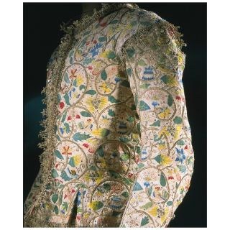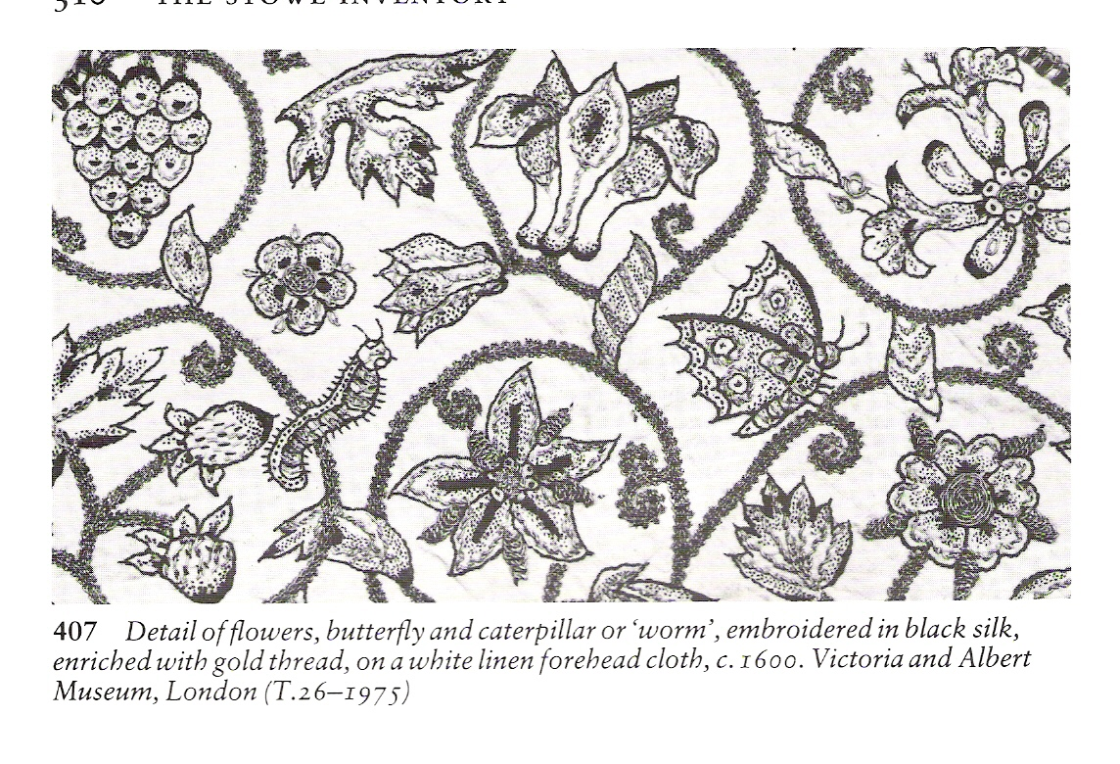

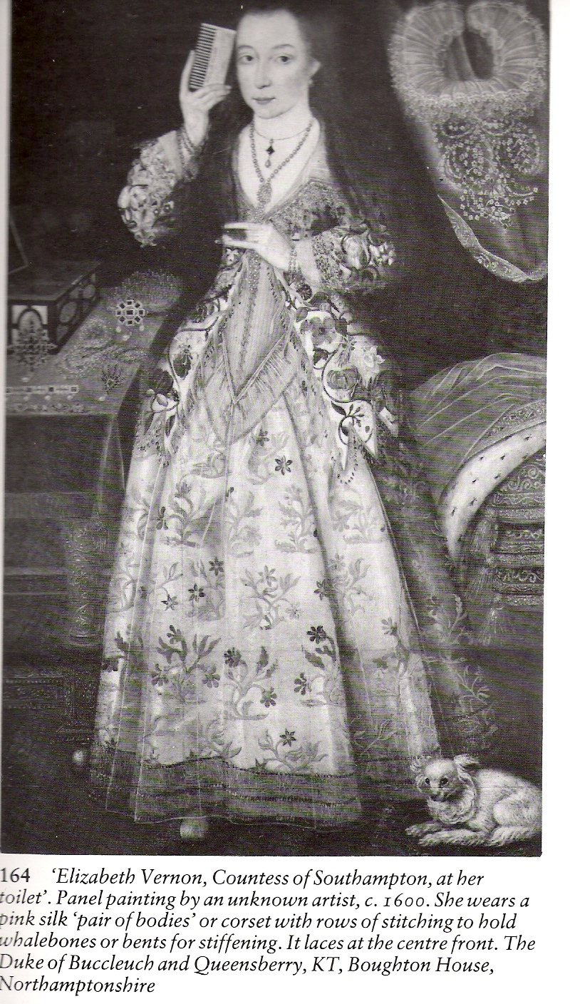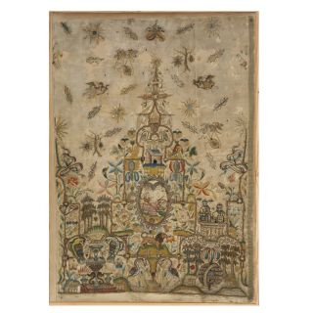
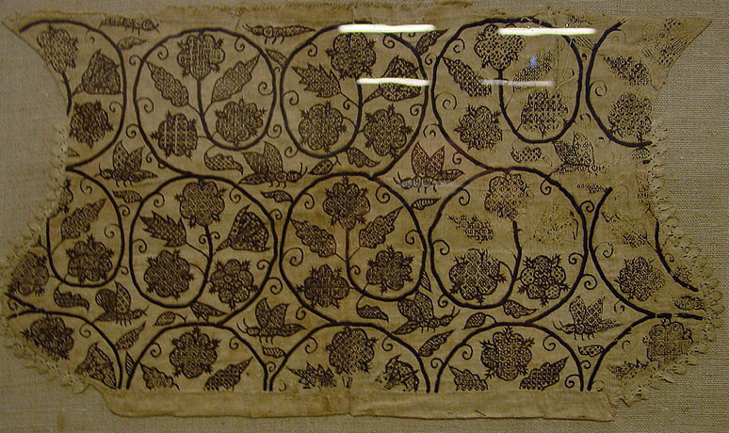

Appendix D
Sweet Bags made by Janet Kempe
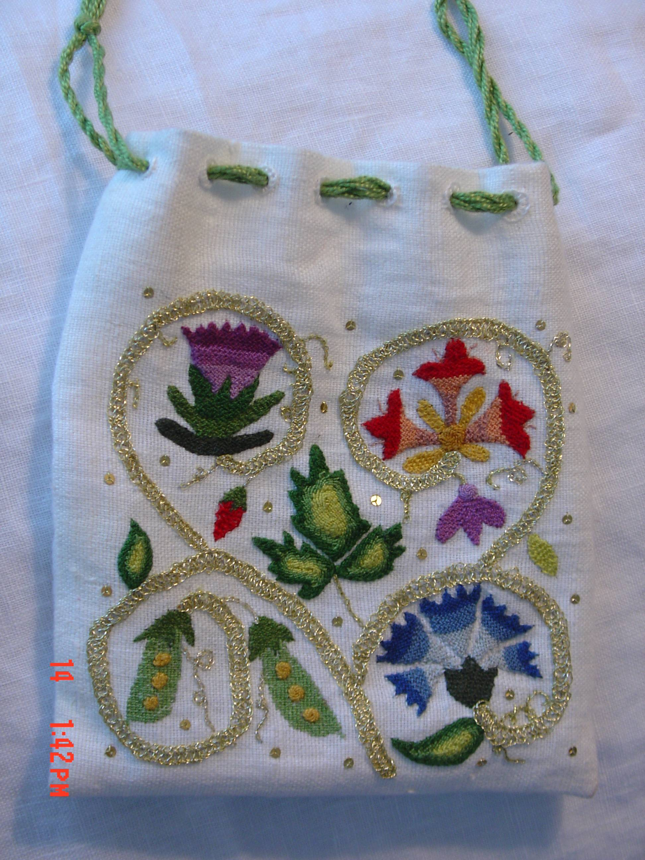
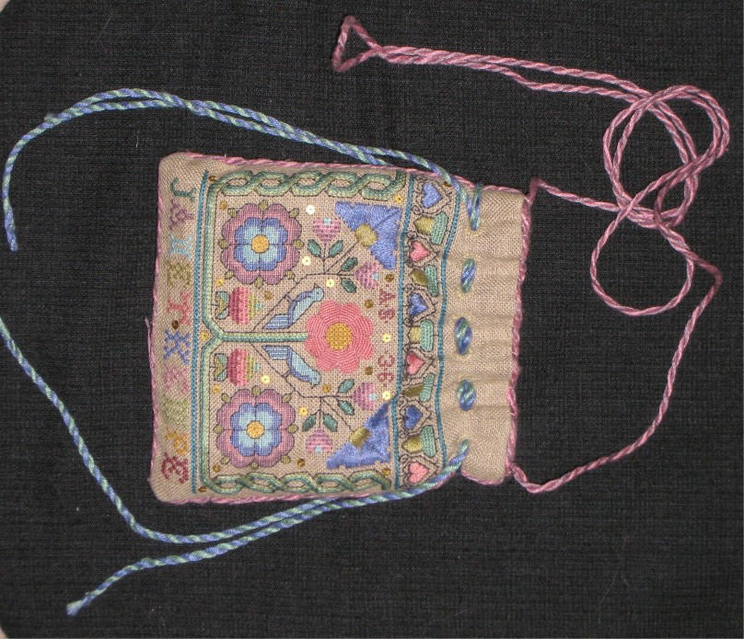
1st Attempt – design from Leisure Arts magazine
2 nd Attempt – design from Fine Lines magazine

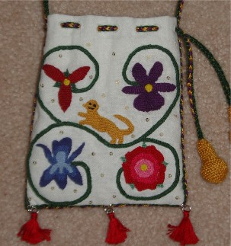
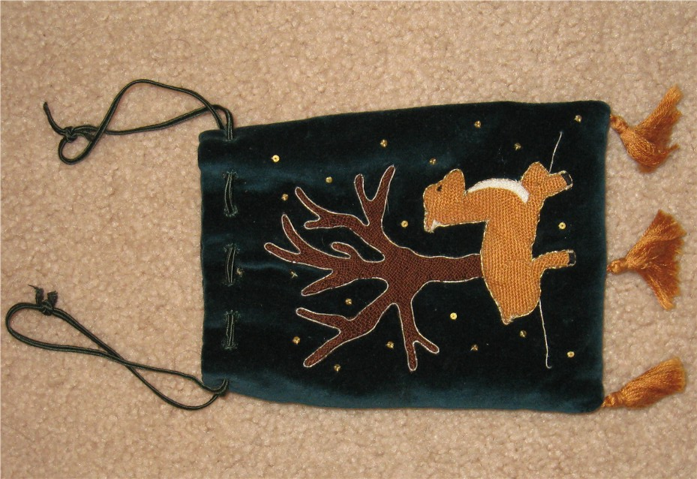
3rd Attempt – own design
4th Attempt – own design

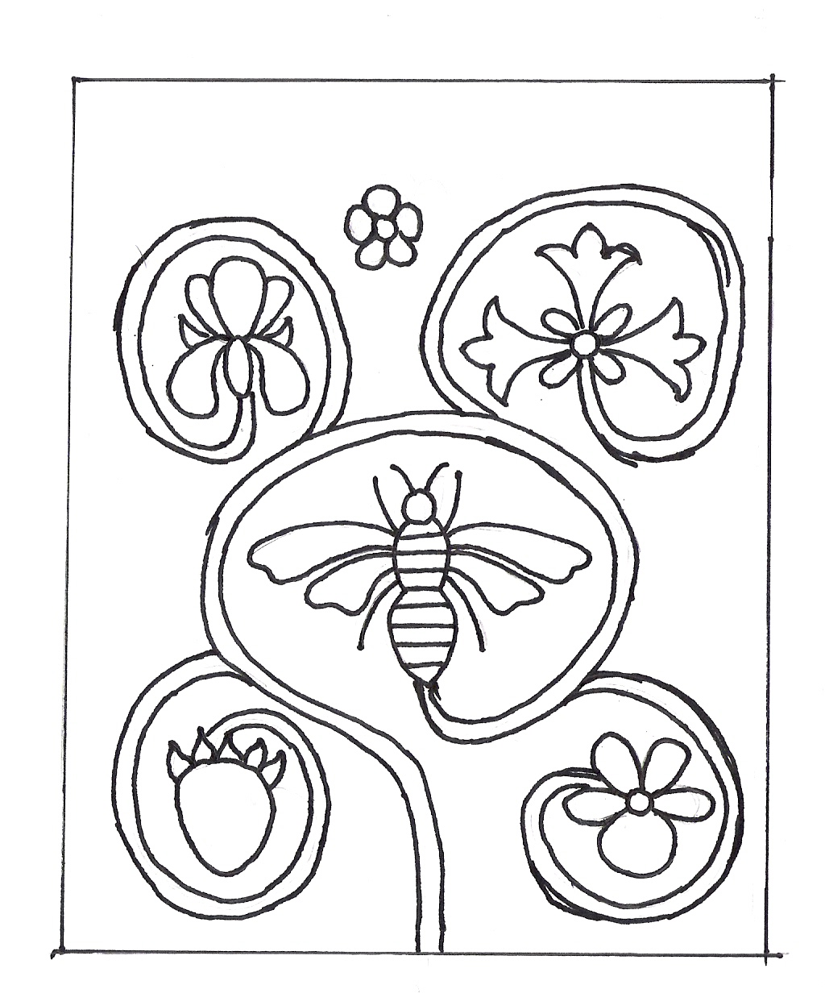
Design for 5th attempt. No finished picture yet.

Digby, George, “Elizabethan Embroidery”, Faber and Faber: London, 1969, page 69
Clarke, Dorothy, “Exploring Elizabethan Embroidery”, Georgeson Publishing Ltd., Auckland, New Zealand, 1997, page 8
Digby, page 21
Clarke, page 8
Ibid., page 8
Digby, page 70
Digby, page 38
Arnold, Janet, “Queen Elizabeth’s Wardrobe Unlocked”, W.S. Maney & Son Ltd, Leeds, Great Britian, 1988, pages 79 and 85-86
Digby, page 27
ibid., page 26
Ibid., page 22
Levey, Santina M, “Elizabethan Treasure: The Hardwick Hall Treasures”, National Trust Enterprises Ltd, London, Great Britain, 1998, page 42

